COURSE CODE : CSA0836

COURSE NAME : PYTHON PROGRAMMING

TEST – 5

1Q PROGRAM TO REMOVE DUPLICATES IN AN ARRAY

def func(a):

b=[]

for i in a:

if i not in b:

b.append(i)

b.sort()

return b

a=eval(input("Enter list:"))

print("The list after removing duplicates is:",func(a))

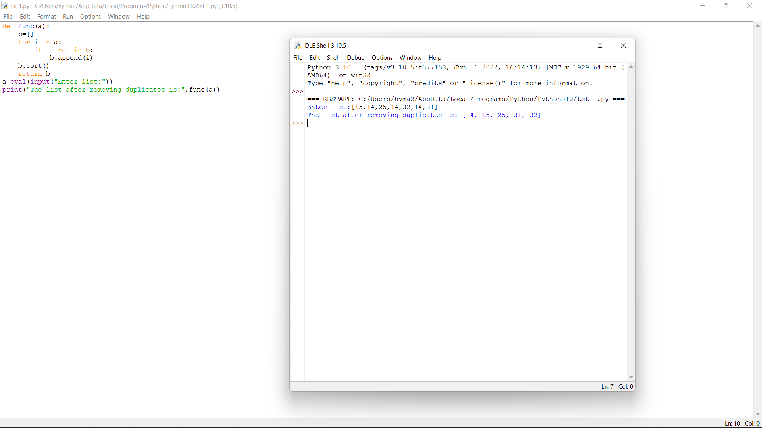

2Q FIND THE NUMBER OF FACTORS FOR A GIVEN NUMBER AND PRONT 1\*N FACTORS

SAMPLE INPUT :

GIVEN NUMBER : 100

N : 4

NUMBER OF FACTORS : 9

1\*4 FACTOR = 1,2,4,5

def factor(n,o):

i=1

count=0

a=[]

while(i<=n):

if (n%i==0):

count+=1

a.append(i)

i+=1

print("Number of factors:",count)

print("1\*",o,"factor is:",a[0:o])

a=int(input("Enter number:"))

o=int(input("Enter N:"))

factor(a,o)

